GCB
• • •• •

Georgia Council of the Blind
P.O. Box 381
Trion, Georgia 30753
The Georgia Council of the Blind is a 501 C (3)
non-profit consumer advocacy organization
affiliated with the American Council of the Blind.
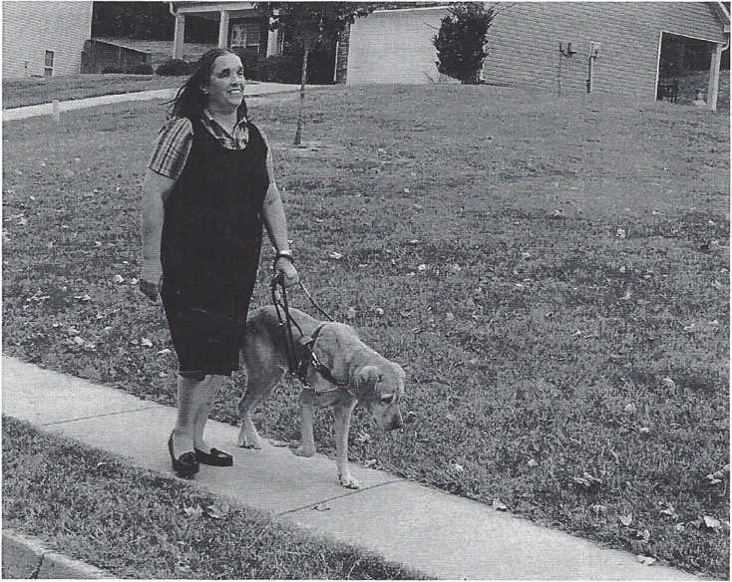

GEORGIA COUNCIL
of the BLIND
An affiliate of the
American Council of the Blind
An organization promoting
a hand up, not a hand out
We strive to elevate the social, economic, and cultural levels of people who are blind or visually impaired. For 60 years GCB has provided a forum for members of the blind community in Georgia to discuss issues that affect our lives and has worked to improve education and rehabilitation, and to broaden vocational opportunities for those who are visually impaired.
CHAPTERS - CONTACT INFORMATION:
The Georgia Council of the Blind has chapters all around the State of Georgia and has at-large members as well. Contact the chapter nearest you to learn about its activities and to get involved.
Athens Chapter: Jerrie Toney,
706-461-1013, ierriemt2@qmail.com:
Augusta Chapter: Deborah Lovell,
706-726-4054, Iovell.d2000@qmail.com
East Georgia Chapter: Neb Houston,
770-784-0236
Greater Columbus Chapter: Gregory McDuffie, 706-330-8185, qreqorv.mcduffie@vahoo.com
Greater Hall County Chapter: Judy Presley, 706-878-2962, Hoval@windstream.net
Northwest Chapter: Ron Burgess, 706-638-1132
Rome Floyd County Chapter: Marsha Farrow, 706-859-2624, marshafarrow@windstream.net
Savannah Chapter: Marj Schneider, 912-352-1415, marischneider@bellsouth.net
South Metro Atlanta Chapter: Lisa Jones, 404-556-8987
Members At Large Representative: Alice Ritchhart, 912-996-4213, alice.ritchhart@comcast.net
GUIDE DOG USERS
Georgia Guide Dog Users is a special interest affiliate of GCB that was established to address the particular concerns of blind and visually impaired Georgians who use guide dogs. The membership of GGDU comes from across the state and includes guide dog handlers and people who raise puppies for guide dog training programs. GGDU focuses on advocacy, public education and support for our members. We advocate and educate on state and federal laws guaranteeing access rights for guide dog handlers, address situations of discrimination when they occur and support our members in the challenges they can face traveling with guide dogs. We meet several times a year, either in person or by phone, and welcome involvement from anyone interested in our activities. For more information, please contact Betsy Grenevitch at 770-464-0450, or via email at blin- dangel@joimail.com. Please visit the website by going to www.qeorqiaquidedoqusers.org
DONATE - VOLUNTEER:
The Georgia Council of the Blind operates solely on the efforts of volunteers who gladly donate their time to further the work of the organization. Please consider making a financial contribution to help GCB cover the cost of our programs and activities.
FOR ADDITIONAL INFORMATION CONTACT THE FOLLOWING GCB OFFICERS:
GCB President, Keith Morris, 706-799-5225, keithmorris53@icloud.com
GCB First Vice-President, Philip Jones, 770-713-3306, brilmanl952@bellsouth.net
GCB Second Vice-President, Fred McDade, 706-278-4084
PEER SUPPORT
Peer support is an important part of GCB because it encourages and assists people who are blind in developing their abilities and potential to become independent and responsible citizens in their communities. Peer support is especially important for those newly diagnosed as visually impaired in dealing with the emotional adjustment to living with vision loss. GCB works hard to educate the public about problems of blindness and the needs and capabilities of people who are blind. We emphasize cooperation with public and private institutions and agencies providing services to those who are blind and visually impaired.
CONFERENCE - CONVENTION - ACTIVITIES
GCB holds a Conference/Convention each year at different locations throughout the state. This event offers timely and informative educational programs as well as recreational and social interaction with members and non-members from all over the State of Georgia. Convention highlights include updates on vocational rehabilitation services and legislation, provides educational workshops and sessions on current technology, and showcases exhibits. Throughout the year GCB activities and programs focus on legislative action, scholarships, peer support, technology, social activities, and braille literacy. Members stay informed on the state and national level through regular publication of the newsletters, The GCB Digest and The Braille Forum.
BECOME A MEMBER OF GCB
Membership dues are only $12 annually and you will be a member of both the Georgia Council of the Blind and the American Council of the Blind. You will also receive regular publications in your format of choice that feature the latest news and events on the issues that impact individuals who are blind and visually impaired.

